**1. What are the various elements of the Excel interface? Describe how they're used.**

**Ans:**

The interface components of Excel include the Quick Access Toolbar, Ribbon, Name Box, Formula Quick Menu, Formula Bar, Status Bar, Worksheet View Options, Zoom Slider Control, and the Zoom Percentage Indicator.

**1. Quick Access Toolbar**



The Quick Access Toolbar is found on the top-left of the Excel window which contains the commonly-used commands in Excel. This toolbar can be customized and lets you choose which commands you want to access easily. By default, this contains the save, undo, and redo commands.

**2. Ribbon**

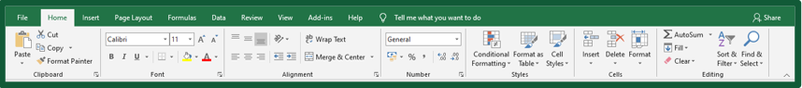

The Ribbon interface contains the commands that are available for use in Excel. This has multiple tabs including the File, Home, Insert, Page Layout, Formulas, Data, Review, View, Add-ins, and Help tabs.

**3. Name Box**

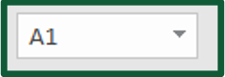

The Name Box is an input box which normally displays the name or location of the active cell on the worksheet. This is also used to directly create a named range. When you open a blank workbook, the selected cell is A1, by default.

**4. Formula Quick Menu**



The Formula Quick Menu beside the Name box is a shortcut when you want to insert a function. If you click the fx option, the Insert Function will pop-up to let you choose which Excel function would you like to use.

**5. Formula Bar**



The Formula Bar is found just beside the Formula Quick Menu. This allows you to enter or edit data, formula or a function that will appear in the selected cell whose name or location appears in the Name Box.

**6. Status Bar**



The Status Bar in the bottom-left corner of the Excel window displays various information about the current mode of the workbook.

**7. Worksheet View Options**



The Worksheet View Options lets you choose which of the 3 worksheet views you want (Normal, Page Layout, or Page Break Preview). By default, the worksheet view is set to Normal.

**8. Zoom Slider Control**

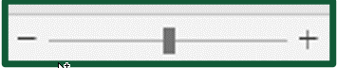

The Zoom Slider Control helps you zoom in and zoom out the worksheet.

**9. Zoom Percentage Indicator**



The Zoom Percentage Indicator displays the zoom percentage just beside the Zoom Slider Control. By default, it is set to 100%.

**2. Write down the various applications of Excel in the industry.**

**Ans:**

1. Business Analysis
2. People Management
3. Managing Operations
4. Performance Reporting
5. Office Administration
6. Strategic Analysis
7. Project Management
8. Managing Programs
9. Contract Administration
10. Account Management

**3. On the ribbon, make a new tab. Add some different groups, insert commands in the groups and name them according to their commands added. Copy and paste the screenshot of the steps you followed.**

**Ans:**

Below are the steps to make a new custom tab in the ribbon in Excel:

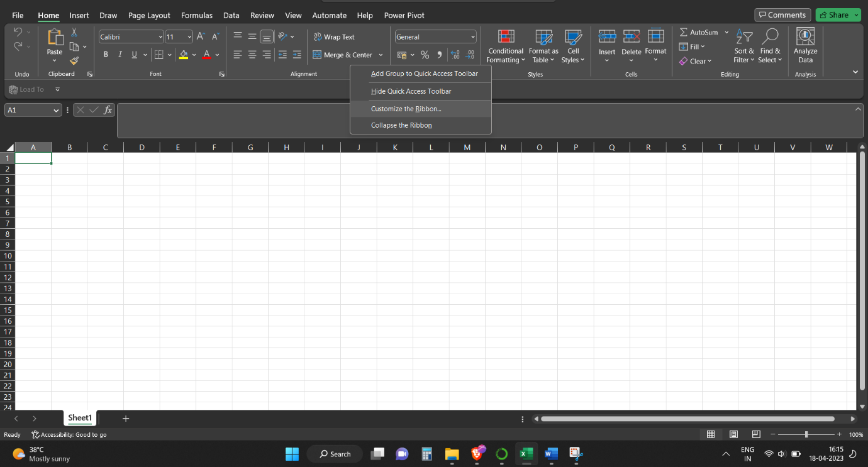

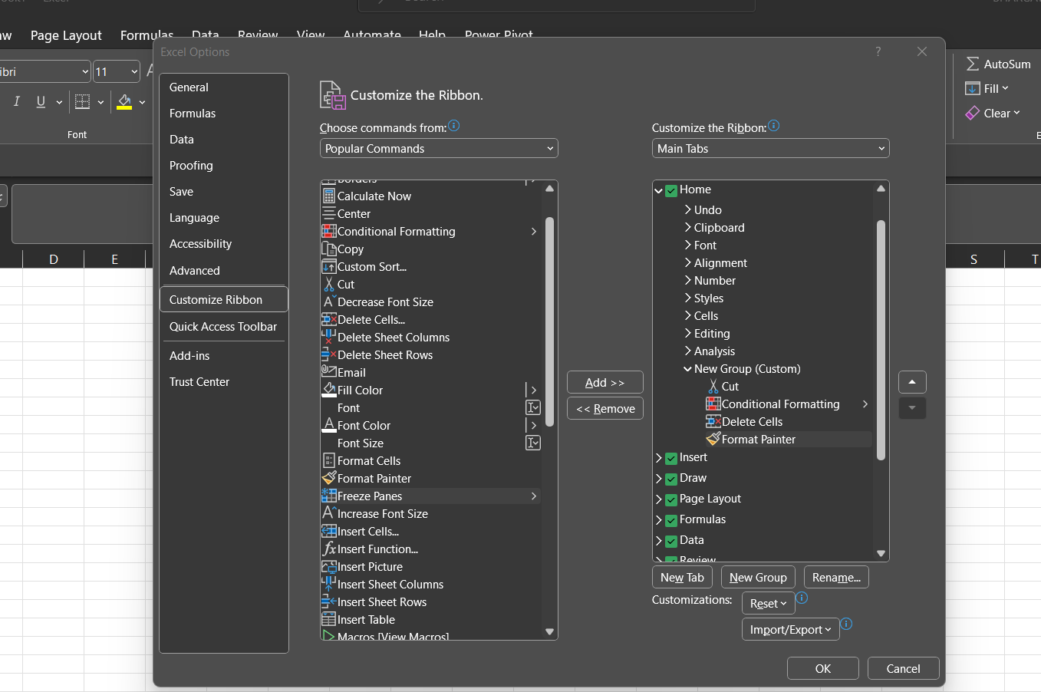

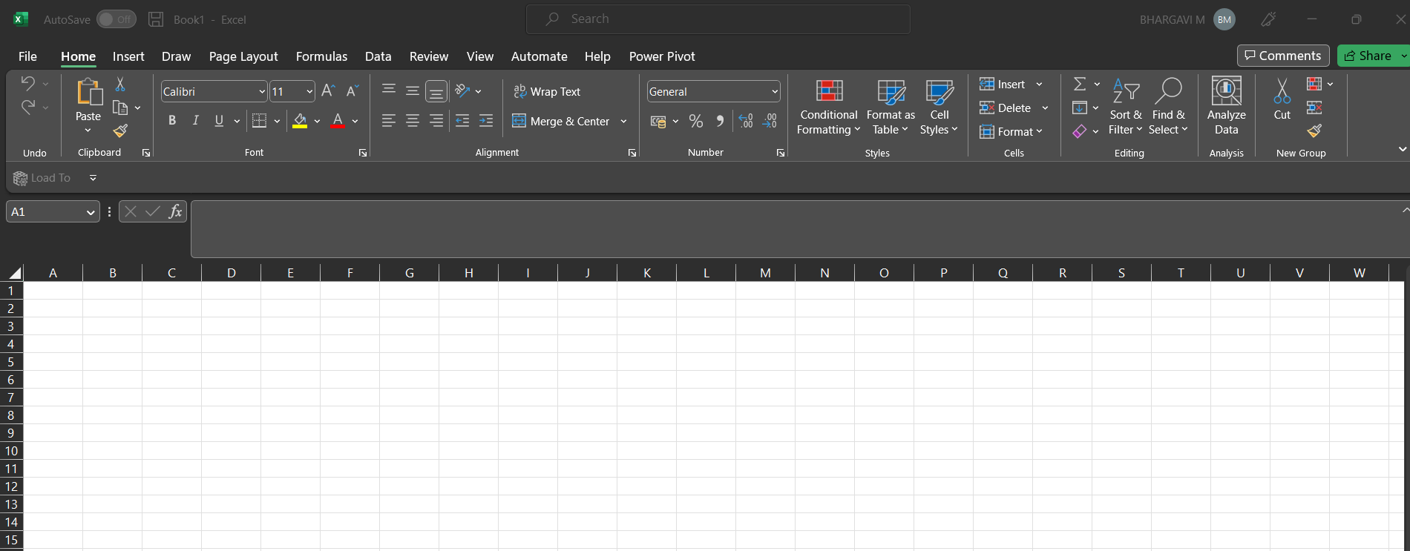

**4. Make a list of different shortcut keys that are only connected to formatting with their functions.**

**Ans:**

* Ctrl+B: Apply bold formatting to the selected cells
* Ctrl+I: Apply italic formatting to the selected cells
* Ctrl+U: Apply underline formatting to the selected cells
* Ctrl+1: Open the Format Cells dialog box
* Ctrl+Shift+~: Apply General number format to the selected cells
* Ctrl+Shift+!: Apply Number format with two decimal places, comma separator and minus sign for negative values
* Ctrl+Shift+$: Apply Currency format with two decimal places and comma separator
* Ctrl+Shift+%: Apply Percentage format with no decimal places
* Ctrl+Shift+^: Apply Exponential number format with two decimal places
* Ctrl+Shift+#: Apply Date format with day, month and year
* Ctrl+Shift+@: Apply Time format with hour, minute and AM/PM
* Ctrl+Shift+&: Apply Border to the selected cells
* Ctrl+Shift+_ (underscore): Remove Border from the selected cells
* Ctrl+Shift+1: Apply Number format with comma separator and no decimal places
* Ctrl+Shift+2: Apply Time format with hour, minute, second and AM/PM
* Ctrl+Shift+3: Apply Date format with day, month and year
* Ctrl+Shift+4: Apply Currency format with two decimal places, minus sign for negative values and parentheses for positive values
* Ctrl+Shift+5: Apply Percentage format with one decimal place, comma separator and minus sign for negative values
* Ctrl+Shift+6: Apply Number format with comma separator, one decimal place and scientific notation

**5. What distinguishes Excel from other analytical tools?**

**Ans:**

Microsoft Excel is a useful tool for the businesses. Companies use the software to organize the data and maximize returns on investment. The large scale organizations have great volume of data from different resources like online sales, in store transactions and the social media. It is important to analyze this information in an efficient manner.

The excel spreadsheet displays financial information in an organized manner. The information could be related to the sales, management department, HR or the marketing. Most of the businesses are dependent on IT sector and therefore excel is a vital tool to run a business. Read on to learn about the topmost features of this software.

* It builds the charts
* It makes use of conditional formatting
* It helps to organize the data
* It will identify trends
* It provides online access

Excel will use range of formulas to unlock the potential of data. You have to insert data in individual cells of columns and rows. In this way, data will be filtered and sorted and hence displayed in a presentable manner. Different types of charts like clustered columns, graphs and pie chart provide great visual presentation. It puts more emphasis to marketing material and business reports. Excel is a wonderful tool to represent data on X and Y axis

**6. Create a table and add a custom header and footer to your table.**

